**Connect MS Access Database in VB.Net**

Step 1: Create an MS Access Database.

Open an MS Access Database in your Computer and Create a Blank Database and Save it as “company.accdb”.

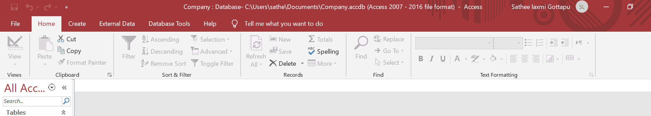

Step 2: Create a Database Table.

To create a table, follow the image below and save it as “employee”.

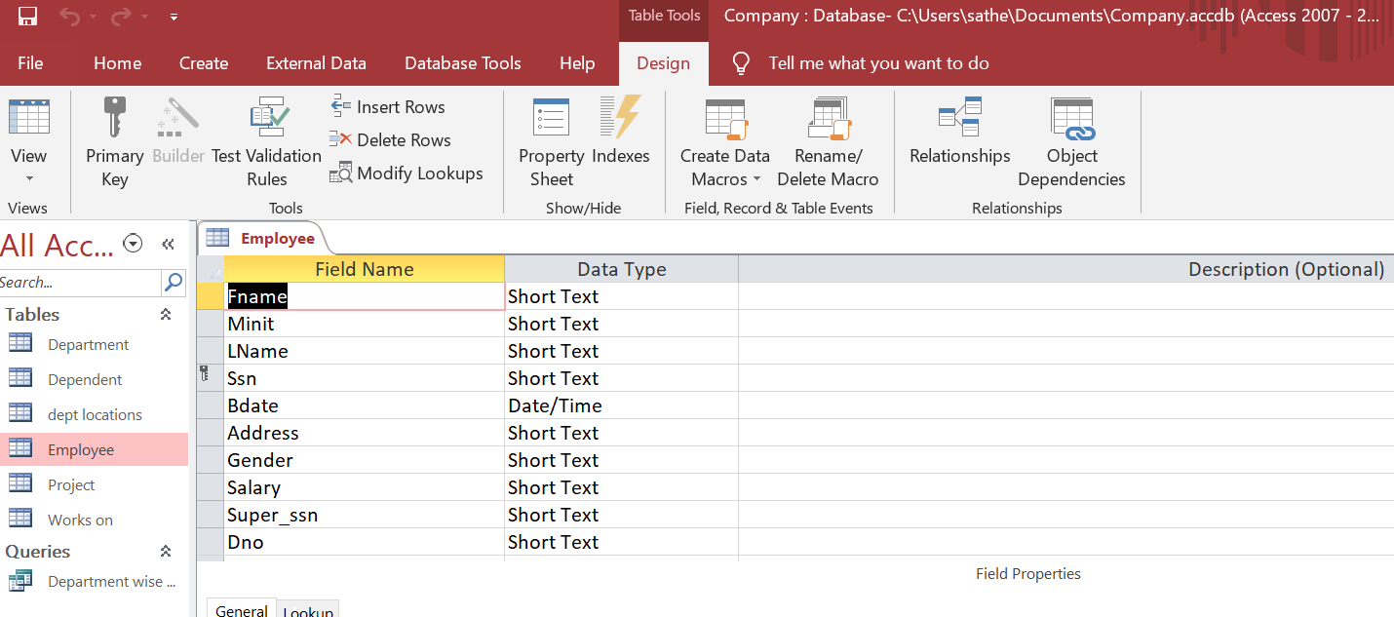

Step 3: Populate the table.

Add sample records in the table. follow the sample records in the image below.

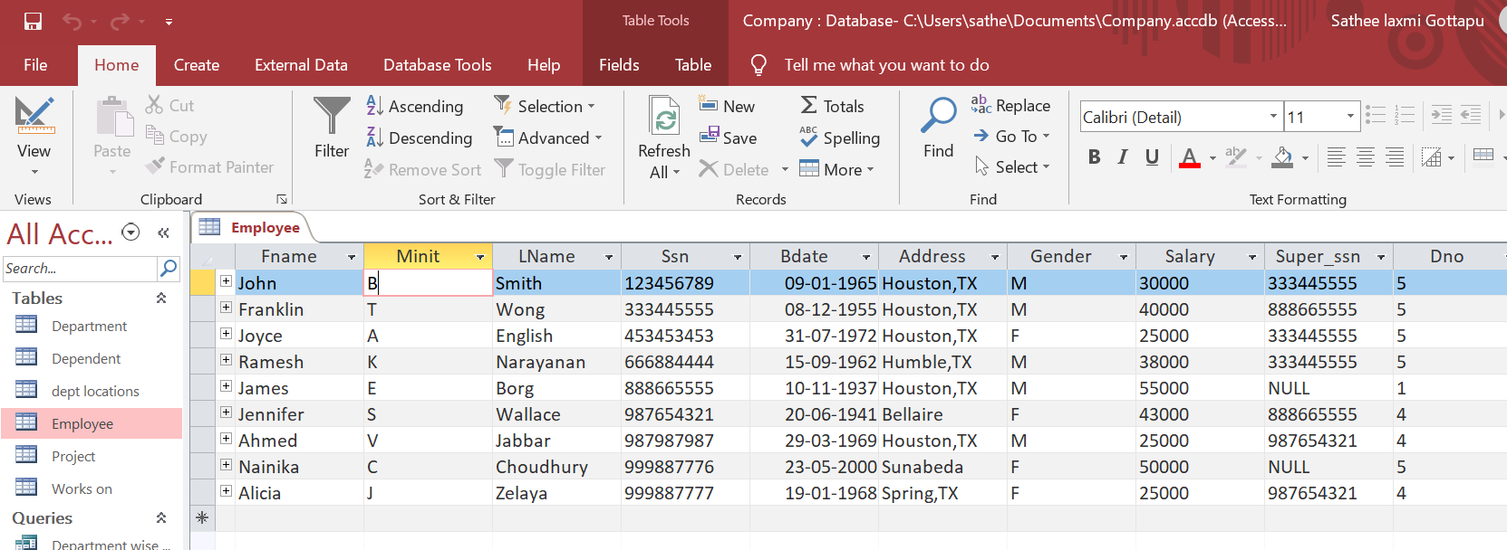

Step 4: Create a VB.Net Application.

Open Visual Studio and Create a Visual Basic Application project and Save it as “database connectivity demo”.

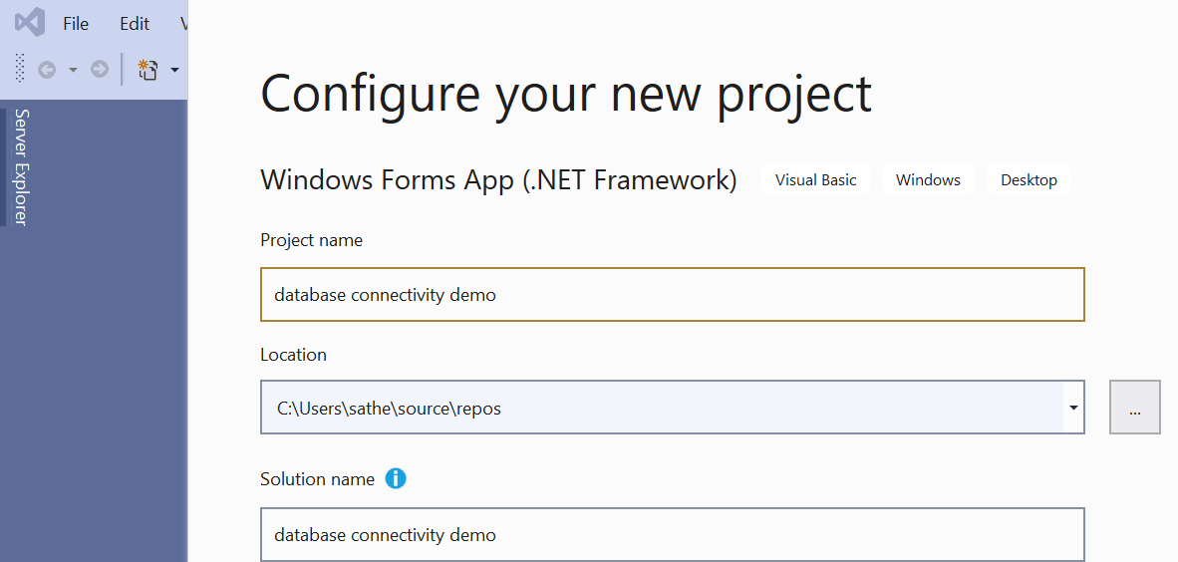

Step 5: Design the user interface.

To design the form, you need to follow the image below.

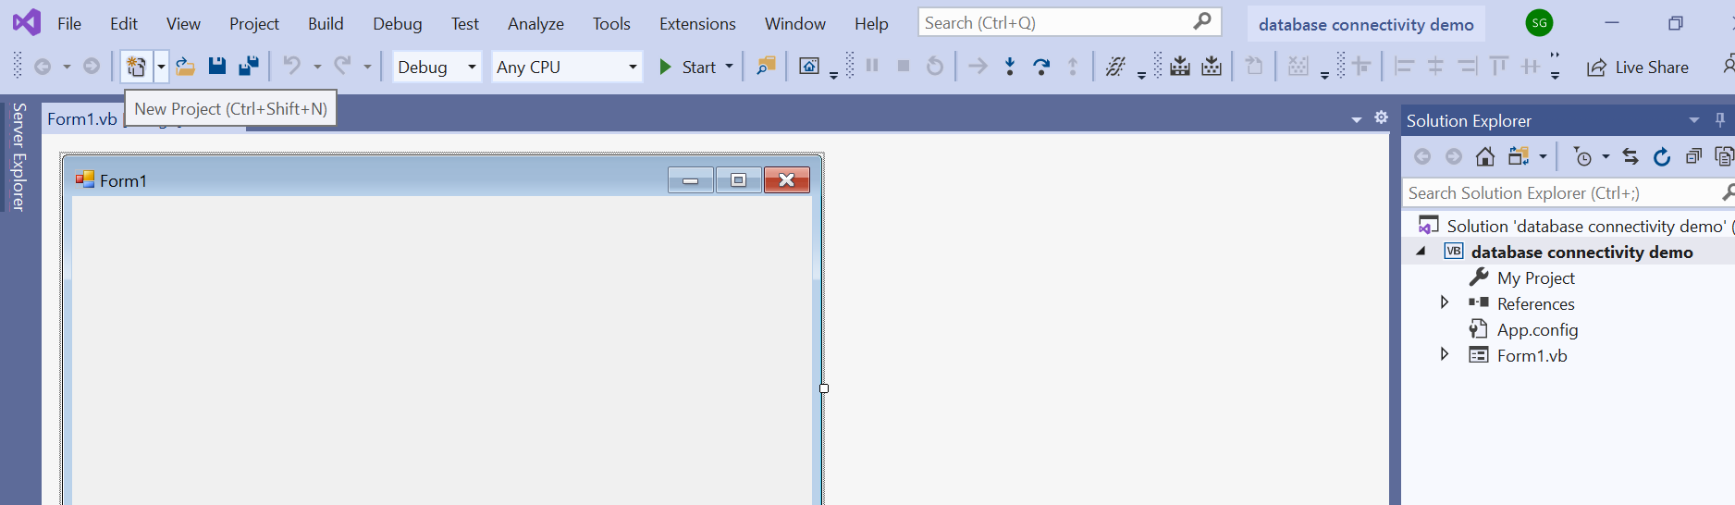

Step 6: Add New Data Source.

On the menu, click data and select “Add new Data Source.”

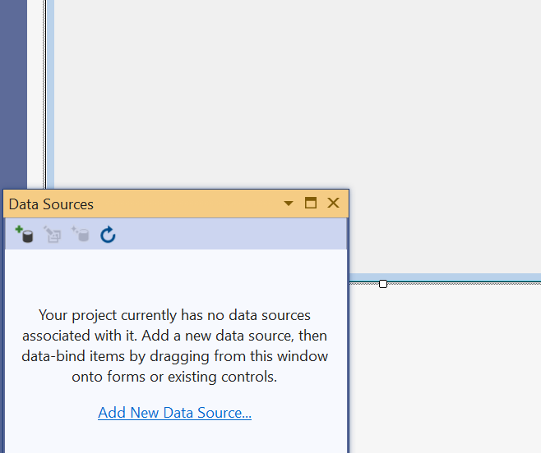

Step 7: Choose a Data Source Type

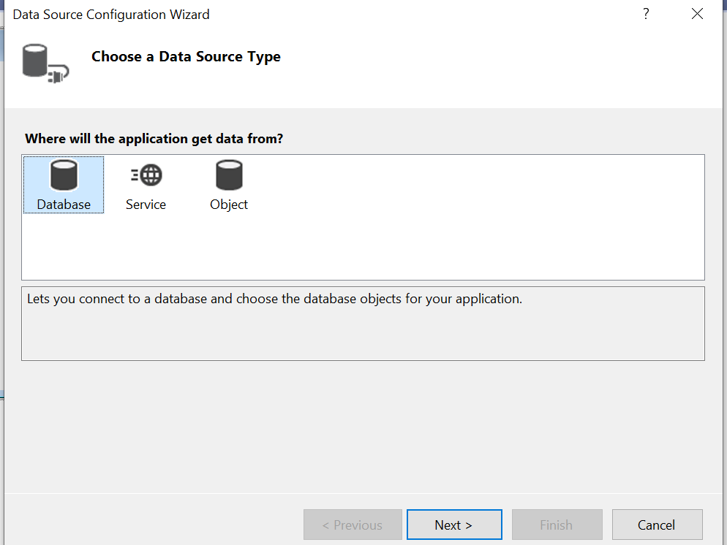

Select Database and click Next.

Step 7: Choose a Data Source

Click new Connection then, Select Microsoft AccessDatabase file and, Click Continue. Follow the image below.

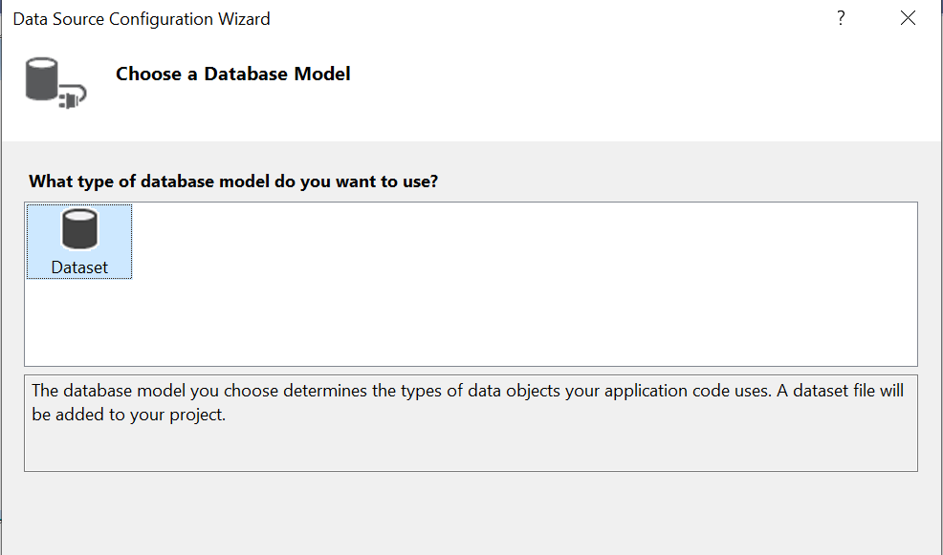

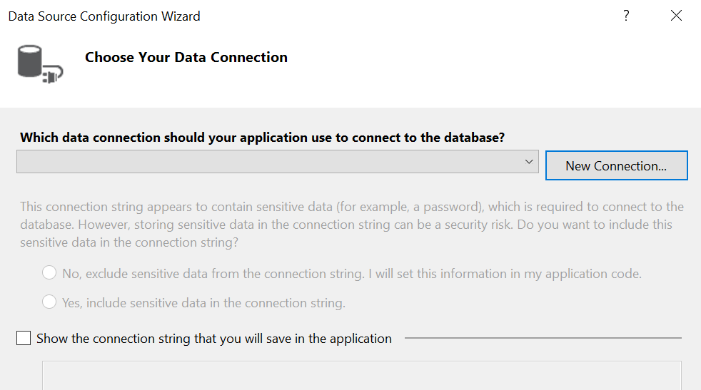

Step 9: Add Connection

First, click Browse Button then, select “company.accdb”, Lastly, Click Open.

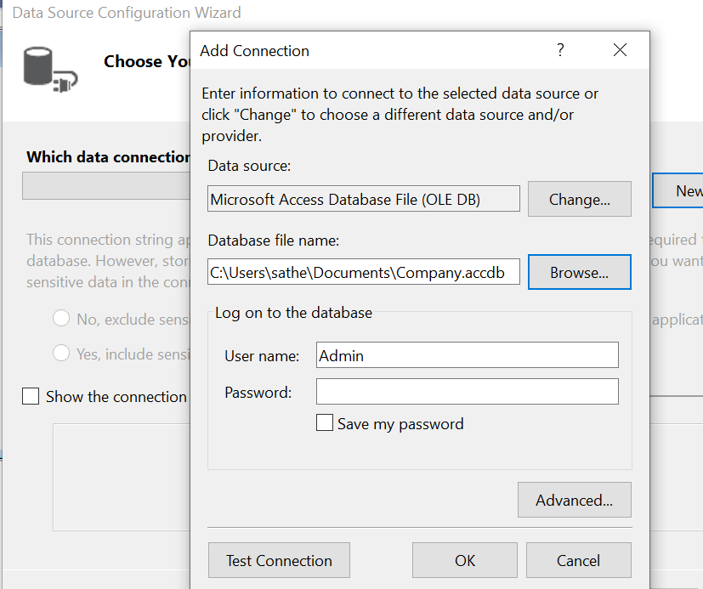

Step 10: Test Connection

To test the connection, click the “Test Connection” button, finally click “OK” button at the side of the “Cancel” button.

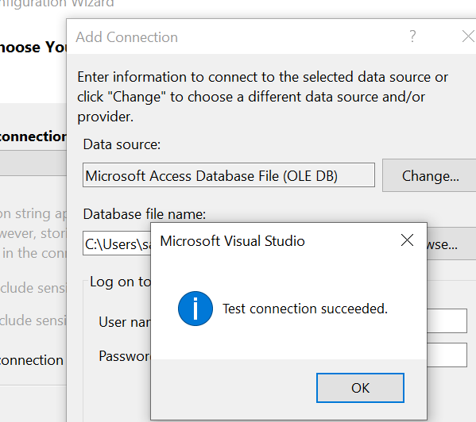

Step 11: Copy the Connection String.

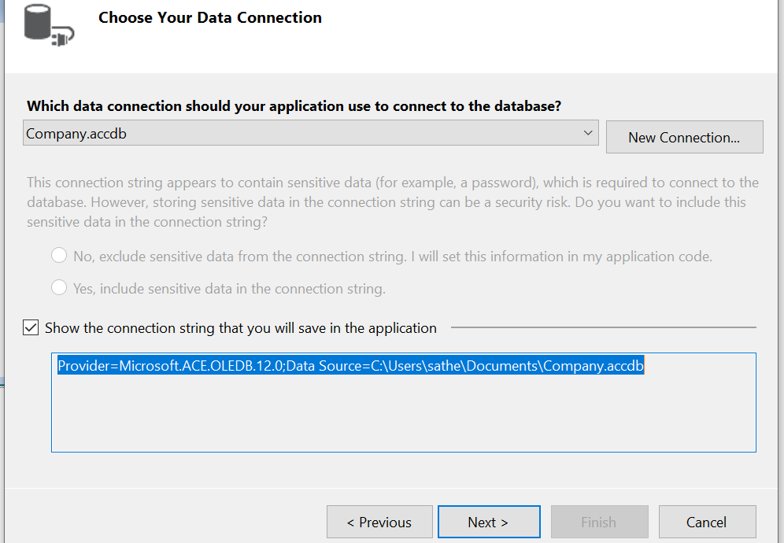

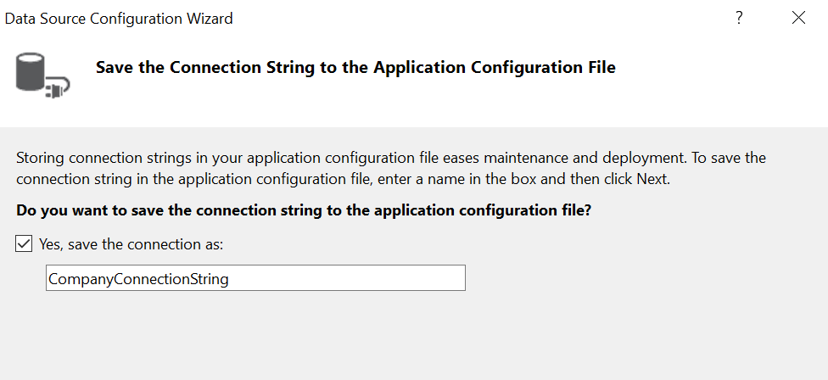

Follow the steps

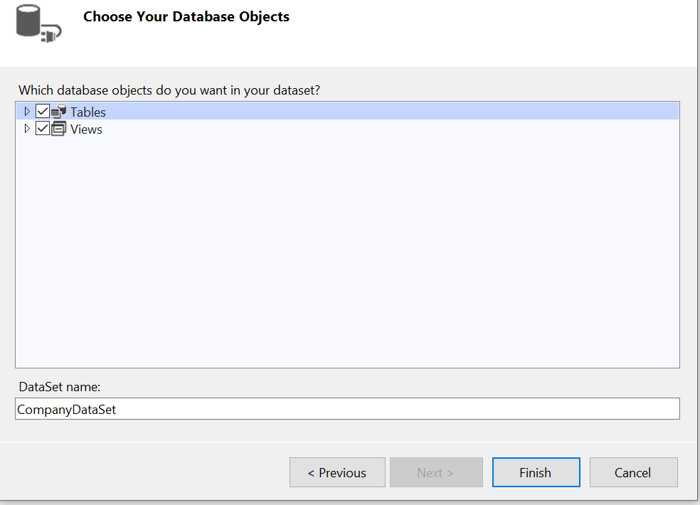

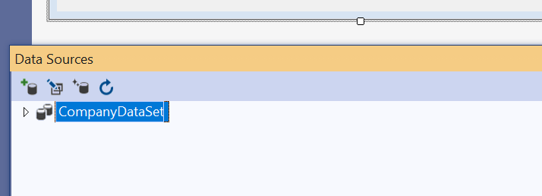

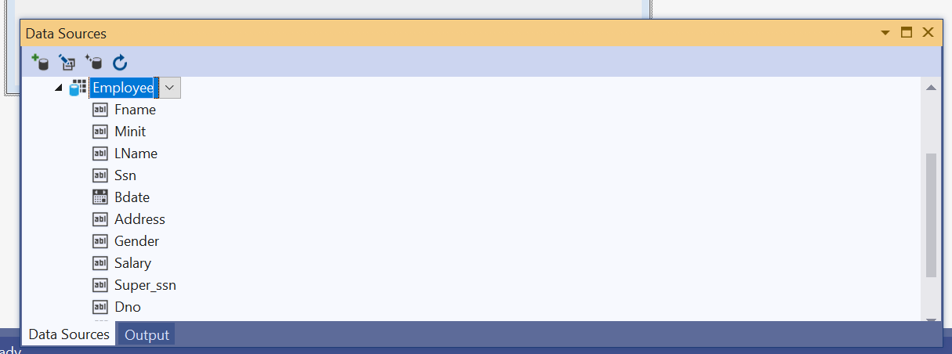

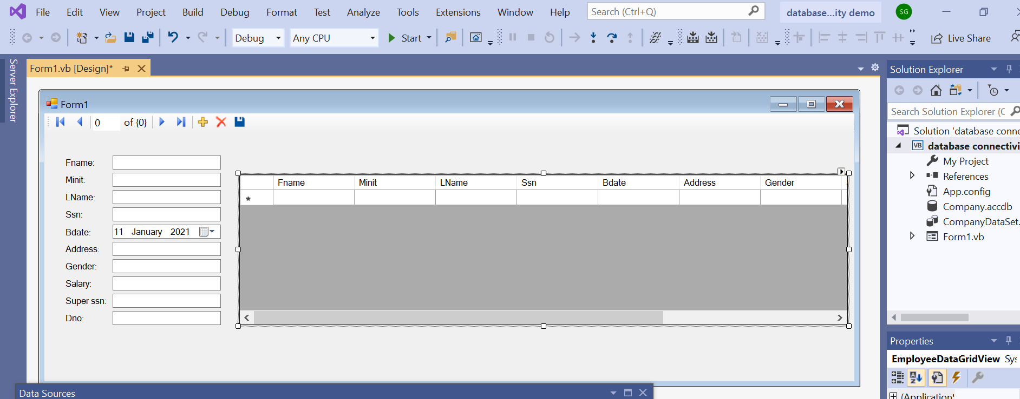

Run the project and observe the following output:

